Sage HRMS Learning Series
Expire Benefits

Updated: October 30, 2019

Contact
Sage Software, Inc.
271 17th Street NW
Atlanta, GA 30363
Phone: 470 - 447 - 4000 www.sage.com
Visit our Web site at www.SageU.com or call (866) 888-6062 to learn about training classes that are added throughout the year.

Copyright / Trademarks
© 2019 The Sage Group plc or its licensors. All rights reserved. Sage, Sage logos, and Sage product and service names mentioned herein are registered trademarks or trademarks of The Sage Group plc or its licensors. All other trademarks are the property of their respective owners. SAP, SAP Crystal Reports, and SAP Crystal Dashboard Design are the trademarks or registered trademarks of SAP AG in Germany and in several other countries. All other trademarks are the property of their respective owners.
The Sage Software logo and the Sage Software product and service names mentioned herein are registered trademarks of Sage Software, Inc. or its affiliated entities. SAP Crystal Reports is the registered trademark and technology of SAP AG, all rights reserved. NetLib is a registered trademark of Communication Horizons. Org Plus is a trademark of Human Concepts, LLC. TextBridge is a registered trademark of ScanSoft, Inc. Microsoft® SQL Server, is a trademark of Microsoft Corporation in the United States and/or other countries. All other trademarks are the property of their respective holders.

Notice / Disclaimer
This document and the Sage HRMS software may be used only in accordance with the accompanying Sage HRMS End User License Agreement ("EULA"). You may not use, copy, modify, disburse or transfer the Sage HRMS software or this documentation except as expressly provided in the license agreement. Nothing in this document supplements, modifies, or amends those terms and conditions.
This material is provided for informational purposes only. Accordingly, Sage does not provide advice per the information included. The use of this material is not a substitute for the guidance of a lawyer, tax, or compliance professional. When in doubt, please consult your lawyer, tax, or compliance professional for counsel.
No license, express, implied, by estoppel or otherwise, to any intellectual property right is granted by this document. Recipient is solely responsible for assessing the suitability of the information and assumes all risk of use.
Sage Software, Inc. has made every effort to ensure this manual is correct and accurate but reserves the right to make changes without notice at its sole discretion. This courseware contains graphics of the actual screens contained in the software. All the screens were captured using a version of sample data that was available at the time of this printing. If you are using a different version of the software, the sample data on the screens may differ slightly from the pictures in this training manual.
Table of Contents
Sage HRMS Training Classes 4
ES - Sage HRMS - Managing your HR Setup in Sage HRMS (Virtual) 4
ES – Sage HRMS – Managing your Employees with Sage HRMS 5
Sage University 5
Expiring Benefits Overview 6
How to Enable Benefit History 6
Show All Benefit Plans vs Show Current Plans Only 6
Data Dictionary 6
Benefit Type Code 8
How to Expire a Benefit Plan 9
Expire a benefit insurance plan for one employee 9
Expire a benefit insurance plan for all employees 9
HR Benefit Reports Pulling Expired Benefits 10
SAP Crystal Reports Pulling Expired Benefits 10
Links and contact information 11

Sage HRMS Training Classes
This learning session uses concepts contained in the following training class on Sage University:

ES - Sage HRMS - Managing your HR Setup in Sage HRMS (Virtual)
Scheduled Training Virtual Classroom 8 hours $549.00 (C$549.00)
During this course we will introduce you to the set up and management of HR code tables in Sage HRMS. Starting with an overview of all HR code tables in the system, we will deep-dive into creating, editing, and managing benefit code tables. We will review the file structure, functions, and expressions, as well as the tool you will use to manage them – Expression Builder. From rate tables to formulas and complex benefit codes containing both, this course will give you a thorough, hands-on approach to managing your setup for Sage HRMS. This training includes hands-on exercises so you can practice what you have learned in a demo environment.
After completing this course, you will be able to:
- Recognize benefits of using code tables
- Explain what code tables are
- Use the manual to:
  - Indicate the use of each table
  - Locate the field that uses the table
  - Indicate whether codes in the table can be changed
    - Use Expression Builder to create formulas and expression in Sage HRMS
    - Enter, manage, and edit codes in Sage HRMS
Who Should Attend?
Any user responsible for creating, editing, and maintaining Code Tables in Sage HRMS. HR Controllers for Sage HRMS (U.S. and Canada)
Prerequisites
Participants should have a cursory knowledge of Sage HRMS.

ES – Sage HRMS – Managing your Employees with Sage HRMS
Scheduled Training Virtual Classroom 16 hours $949.00 (C$949.00)
During this course we will explore the features and functionality available in Sage HRMS HR and Sage Abra Suite HR. Topics will include using the navigation pane, the user preferences, and the employee toolbar to manage your employee data. We will review the file structure in Sage HRMS, the various HR detail pages, and the tasks and processes needed to manage HR, whether it is for one employee or a group of employees. We will also discuss time off management, as well as the reporting capabilities available in Sage HRMS with standard reports and the secure query. This training includes hands-on exercises so you can practice what you have learned in a demo environment.
After completing this course, you will be able to:
- Operate the Employee Toolbar to promptly navigate employee information
- Quickly and efficiently update your employee information using Tasks and Processes in Sage HRMS
- Make use of Sage Abra/Sage HRMS canned reports to give the metrics you need when you need them
- Interpret and apply best practices when using the Sage Abra/Sage HRMS User Interface for improved management of your HR processes
Who Should Attend?
Sage HRMS and Sage Abra Suite users who are required to access and update employee HR information.
Prerequisites
None

Sage University
To find training and register for training courses, visit Sage University at www.sageu.com. If you have Gold Support, you are entitled to 50% off Sage HRMS instructor-led training and Sage HRMS Any-time learning (ATLs) are free. If you register for an instructor-led training class, use code HRMSresource to receive 10% off. If you have Gold Support, this is in addition to the 50% discount.
To enroll in a course, go to https://sageu.csod.com and log on. If you do not have a log on, you will need to create one. For registration assistance call Sage University Help Desk at 1-855-724-3864 or email SageUniversity@sage.com.

Expiring Benefits Overview
In today’s Learning Session we will:
- Enable Benefit History
- Review the data dictionary and benefit type codes
- Discuss the difference between a history record and an expired benefit
- Expire a benefit insurance plan for one employee
- Expire a benefit insurance plan for all employees
- Look at solutions to stop expired benefits from appearing on standard HR benefit reports and SAP Crystal Reports

How to Enable Benefit History
Path: Setup > System > (Setup) Enterprise Setup
The Benefit History radio buttons provide the ability to enable or disable benefit history. The default option is disabled.
If benefit history is disabled and is changed to enabled, going forward it will save history records. When the setting is disabled, Sage HRMS is not saving benefit history records.

Show All Benefit Plans vs Show Current Plans Only
Path: Settings > User Preferences > General Preferences tab
In User Preferences you can select the default for the employee’s Insurance Benefit Page to ‘Show All Benefit Plans’ or ‘Show Current Plans Only’.
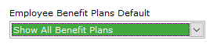

Data Dictionary
The Data Dictionary documents the structure for the tables used by the HR module of Sage HRMS. It is useful when building expressions within Sage HRMS and when deciding what fields to use for your custom reports.
You can access the Data Dictionary though Sage HRMS Online Documentation or Sage HRMS Help. In order to obtain the most accurate and up-to-date data dictionary, run the Data Dictionary Reports by selecting Reports > System > Data Dictionary Reports.
We will focus on the Employee Benefit (BE) table.
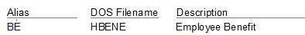
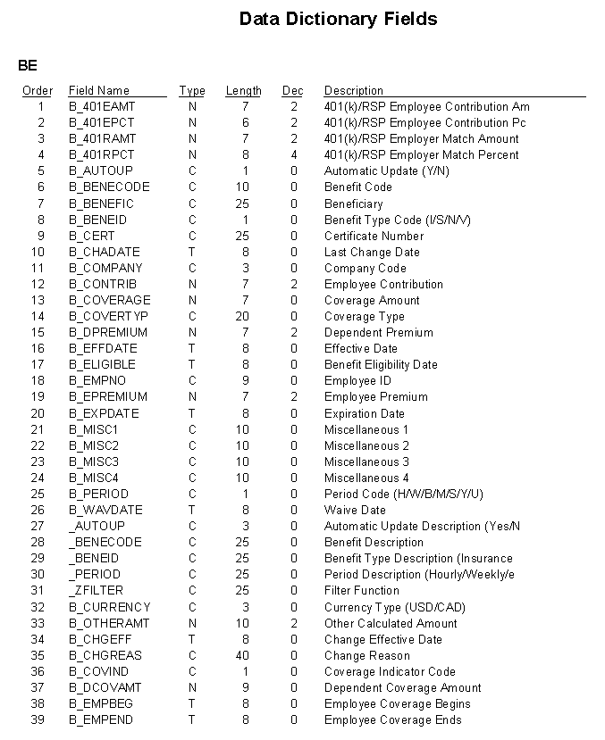

Benefit Type Code
The field B_Beneid is a character field. The description is Benefit Type Code (I/S/N/V)
Legend for Be.b_beneid
I | Current Insurance or expired plan
S | Current Savings
N | Insurance History
V | Savings History

Not all expired plans are history records.

When you expire a benefit for an employee the Be.b_beneid field remains “I”. The Be.b_expdate contains the Expiration Date.
When benefit history is enabled, depending on the type of change that is made (for example, adding a covered dependent or causing an amount change), a history record is created, and the new information is now the current record.
When ‘Include History Records’ is selected on the employees Insurance Benefit page, the Current record appears bolded and history records are not bolded. In the screen shot below, DENTAL has a current bolded record (Last Change 07/08/2019) and a history record (Last Change 03/01/2010).

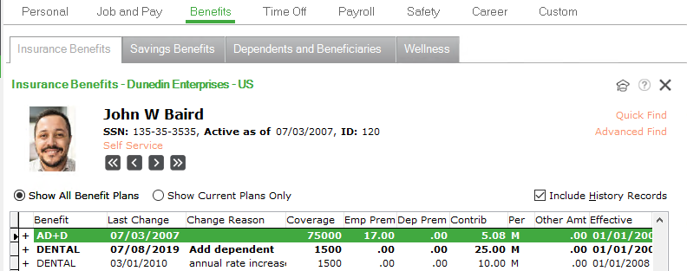

How to Expire a Benefit Plan

Expire a benefit insurance plan for one employee
Path: Employees > (Tasks) View/Edit Employee > Benefits tab > Insurance Benefits tab
- Make sure you have selected the employee that will have the plan expired
- Click on the benefit record you want to expire. Click More
- Click Expire Benefit
- Enter the expiration date in Coverage Expiration Date field. Click OK
- Employee Coverage Ends date will be updated. Click OK to save
- In the Summary View scroll to the far right and the Expiration field will display the date entered you entered above
Note: If Coverage Expiration Date is prior to the system date and benefit history is enabled, the benefit will no longer appear under the option ‘Show Current Plans Only’. If Coverage Expiration Date is equal to or greater than the system date, the benefit will appear in ‘Show Current Plans Only’ and ‘Show all Benefit Plans’.

Expire a benefit insurance plan for all employees
Path: Setup > (Codes) Employees > (Benefits) Insurance Plans
- Select the Employer field where the code is being pulled from. If the code exists at the employer level select the employer, if the code is not at the employer level select *** Enterprise
- Click on code to be expired and click More
- Enter the date to expire the plan in the ‘Plan Is In Effect To’ field
- Click OK
- A message will appear
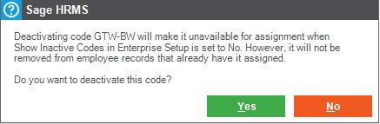
Click Yes to deactivate this code. If you do not want to deactivate the code click No
- If you click Yes in the previous step, an Expiration Date Warning Message will appear
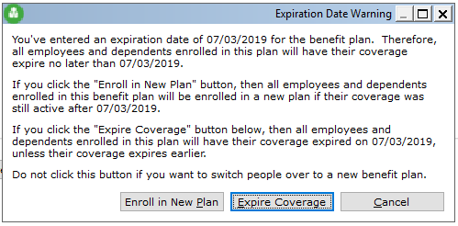
- Select the appropriate button for your scenario
If Expire Coverage is selected, the Be.b_beneid field will remain ‘I’ since the b_expdate field has been updated. The record line was not replaced. If Enroll in New Plan is selected the Be.b_expdate will be updated and be.b_beneid will remain ‘I’.
Expiring a Benefit Savings plan is similar to expiring an insurance benefit plan. It can be done in Setup for all employees or one employee at a time on the employee Savings Benefit page.

HR Benefit Reports Pulling Expired Benefits
If a standard HR benefit report is pulling expired benefits and you want to see current benefits only, enter the following Visual FoxPro Expression on the reports’ Standard Criteria tab > Custom Criteria.
(isnull({hbene.b_expdate})or
{hbene.b_expdate}=datetime(0,0,0,0,0,0) or
{hbene.b_expdate} >= CurrentDate)
and
{hbene.b_beneid} in ["I", "S"]
Some benefit reports have the option on the Specific Criteria tab to select/deselect ‘Include History Records’.

SAP Crystal Reports Pulling Expired Benefits
To see active benefits as of a specified date (June 30, 2019)
- From the Crystal Report Menu select Report, Edit Selection Formula, and Record
- Paste in all three lines of ONE of the following formulas:
{hbene.b_beneid} in ["I", "S"] and
({hbene.b_expdate} >= Date (2019, 06, 30) or
{hbene.b_expdate} = Date (0, 0, 0))
OR instead of having to replace 'Date (2019, 06, 30)' with the current or desired date;
({hbene.b_expdate} >= CurrentDate or
{hbene.b_expdate} = Date (0, 0, 0)) and
{hbene.b_beneid} in ["I", "S"]

Links and contact information
Topic | URL | Additional Information
Sage City – HRMS Forum | https://www.sagecity.com/support_communities/sage_hrms/f | Ask product questions  Share tips and tricks with Sage peers, partners, and pros
Questions and Answers relating to Sage HRMS Learning Series | https://www.sagecity.com/support_communities/sage_hrms/f/sage-hrms---training | This link will take you directly to the Sage HRMS – Training forum on Sage City
Sage University | https://www.sageu.com/hrms | Log on  Training and certification  View training by subject  Create a Profile  Test your knowledge  View training schedule
Sage University Help Desk |  | Telephone: 1-855-724-3864  Email: SageUniversity@sage.com
Discount code when registering for Sage HRMS instructor-led training | HRMSresource | 10% off
Register or access on demand recording for Sage HRMS Learning Series | https://get.sage.com/HRMSLearningSeries
Grad Cap icon in Sage HRMS |  | A link to Sage University to browse for training on the related area in Sage HRMS

